Information for IAM

VENUE FOR THE MEETING
Hungarian Food Safety Office (HFSO)
Tábornok u. 2. (B. building)
H-1143 Budapest
HUNGARY

TRANSPORT TO HFSO/CITY CENTRE FROM THE AIRPORT

Budapest Liszt Ferenc Airport
The Airport (Terminal 1, 2A and 2B) is located approximately 16 kilometres southeast of the city centre. All terminals are accessible by public transport, private car, shuttle bus as well as by taxi. For further information visit: www.bud.hu/english
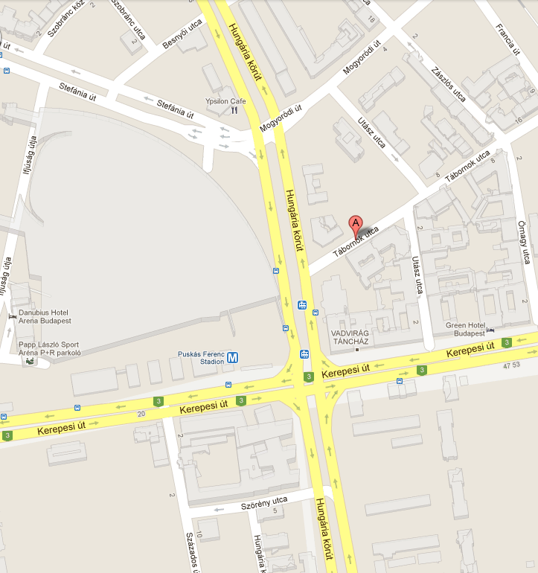
TRAM line 1 /1A
Station for HFSO

Shuttle bus
A reliable and reasonable transfer option for travelling between the Airport and any point of Budapest is the AirportShuttle-Minibusz. The transfer operates as a shared ride service, which means that passengers who are bound to the same direction, or are coming from the same direction to the Airport are escorted in the same vehicle. Reservations can be made in person at the AirportShuttle-Minibusz Desks or 24 hours before your flight departure via the internet online reservation system or by calling the Call Center at (+36-1) 296-8555. For further information visit: www.airportshuttle.hu/en

Taxi
Főtaxi (the official partner of Budapest Airport) carries passengers from the Airport to any point of Budapest. International bank cards, credit cards are accepted for payment. From 1 September 2013 a new Taxi Decree was introduced in Hungary regulating the price* of the taxis at a fixed tariff of 280 HUF/Km (0.95 EUR/Km) in addition to the one-off basic fee of 450 HUF (1.50 EUR) and waiting fee. A ride to the city center should typically cost around 6500 HUF (22 EUR) depending on traffic conditions.
Please be aware that the use of non-regulated taxi service providers soliciting at the terminal buildings may expose your to risk.
For further information visit: http://www.fotaxi.hu/taxi-budapest-eng.php?oldal=english-taxi-budapest
Taxi is the best option if 2 or more people are travelling together.

Public Transportation

See attached map
You may get to the HFSO from the city centre by tram line 1 commuting on the Hungaria körút. The second option is to take metro line 2 (red line) and get of at Puskás Ferenc Stadionok’. (it is indicated on the ‘old’ metro map as Stadionok). You should look for exit Hungaria körút and proceed through the ‘underground’ pedestrian pathway.

- Useful link:
You can find more information about Hungary on www.hungary.com
You can travel between the airport and the city centre by bus/subway: www.bud.hu/en/passengers/transport/public_transportation/budapest_public_transportation

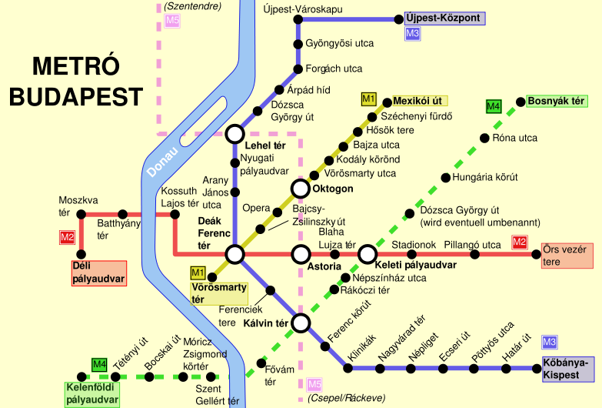

Get off for HFSO here

